1. Write a program to convert the given text into hexadecimal representation:
Input: “Your lips are smoother than vaseline”

Output: 596F7572206C6970 732061726520736D 6F6F746865722074 68616E2076617365 6C696E650D0A

CODE:

#include<bits/stdc++.h>
using namespace std;

void string2hex(const string str, string& hexstr, bool capital = true) {
hexstr.resize((str.size() * 2));
const size_t a = capital ? 'A' - 1 : 'a' - 1;
for (size_t i = 0, c = str[0] & 0xFF; i < hexstr.size(); c = str[i / 2] & 0xFF) {
hexstr[i++] = c > 0x9F ? (c / 16 - 9) | a : c / 16 | '0';
hexstr[i++] = (c & 0xF) > 9 ? (c % 16 - 9) | a : c % 16 | '0';
}
}

int main(){
string s = "Your lips are smoother than vaseline";
cout << "\n\tOriginal String: " << s << '\n';
string2hex(s, s);
s = s + "0D0A";
cout << "\n\tHexadecimal Format: " << s << "\n\n";
return 0;
}

OUTPUT:

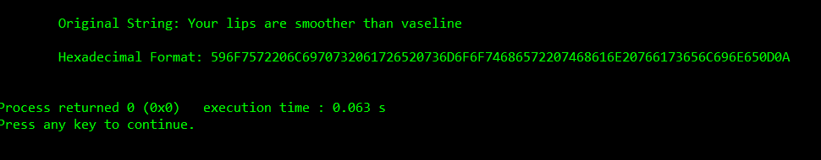

- Write a program to convert a given hexadecimal key
K = 133457799BBCDFF1 into 56-bit key K+ using permutation PC-1.
PC-1

57 49 41 33 25 17 9
1 58 50 42 34 26 18
10 2 59 51 43 35 27
19 11 3 60 52 44 36
63 55 47 39 31 23 15
7 62 54 46 38 30 22
- 6 61 53 45 37 29
21 13 5 28 20 12 4

CODE:

#include<bits/stdc++.h>
using namespace std;

int main() {

// string K = "133457799BBCDFF1";
string K;
cout << "\n\n\tEnter The Hexadecimal String : ";
cin >> K;
int PC1[56] = {57, 49, 41, 33, 25, 17, 9, 1, 58, 50, 42, 34, 26, 18, 10, 2, 59, 51, 43, 35, 27, 19, 11, 3, 60, 52, 44, 36, 63, 55, 47, 39, 31, 23, 15, 7, 62, 54, 46, 38, 30, 22, 14, 6, 61, 53, 45, 37, 29, 21, 13, 5, 28, 20, 12, 4};

int KPlus[56];

string hex[16] = {"0", "1", "2", "3", "4", "5", "6", "7", "8", "9", "A", "B", "C", "D", "E", "F"};

string bits[16] = {"0000", "0001", "0010", "0011", "0100", "0101", "0110", "0111", "1000", "1001", "1010", "1011", "1100", "1101", "1110", "1111"};

string bin[(sizeof(K) / sizeof(K[0]))];

for (int i = 0; i < (sizeof(K) / sizeof(K[0])); i++)
{
if (K[i] == '0') bin[i] = bits[0];
if (K[i] == '1') bin[i] = bits[1];
if (K[i] == '2') bin[i] = bits[2];
if (K[i] == '3') bin[i] = bits[3];
if (K[i] == '4') bin[i] = bits[4];
if (K[i] == '5') bin[i] = bits[5];
if (K[i] == '6') bin[i] = bits[6];
if (K[i] == '7') bin[i] = bits[7];
if (K[i] == '8') bin[i] = bits[8];
if (K[i] == '9') bin[i] = bits[9];
if (K[i] == 'A') bin[i] = bits[10];
if (K[i] == 'B') bin[i] = bits[11];
if (K[i] == 'C') bin[i] = bits[12];
if (K[i] == 'D') bin[i] = bits[13];
if (K[i] == 'E') bin[i] = bits[14];
if (K[i] == 'F') bin[i] = bits[15];
}
cout << "\n\n\tK (Hexa Str) : " << K;

cout << "\n\n\tK (64 bits) : ";
for (int l = 0; l < sizeof(K) / sizeof(K[0]); l++) cout << bin[l] << " ";

for (int kp = 0; kp < 56; kp++)
{
KPlus[kp] = int(bin[PC1[kp] / 4][PC1[kp] % 4]) - 48;
}

cout << "\n\n\tK+ (56 bits) : ";

for (int u = 0; u < 56; u++)
{
if ((u+1) % 4 != 0) cout << KPlus[u];
else {
cout << KPlus[u] << " ";
}
}
cout << "\n\n";

return 0;
}

OUTPUT:

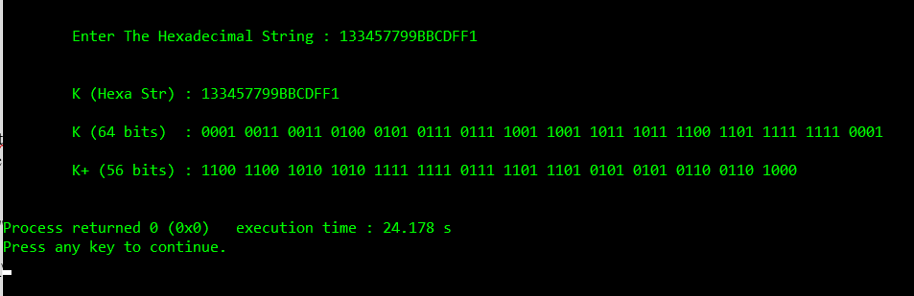

- From the above key K+, find the C1 and D1, C2 and D2, C3 and D3 using the left shift as per below information:
Iteration Number Number of Left Shifts
1 1
2 1
3 2
4 2
5 2
6 2
7 2
8 2
9 1
10 2
11 2
12 2
13 2
14 2
15 2
16 1

CODE:

#include<bits/stdc++.h>
using namespace std;

int main() {
int KPlus[56] = {1, 1, 0, 0, 1, 1, 0, 0, 1, 0, 1, 0, 1, 0, 1, 0, 1, 1, 1, 1, 1, 1, 1, 1, 0, 1, 1, 1, 1, 1, 0, 1, 1, 1, 0, 1, 0, 1, 0, 1, 0, 1, 0, 1, 0, 1, 1, 0, 0, 1, 1, 0, 1, 0, 0, 0};
int C0[28], D0[28];
int itr[16] = {1, 1, 2, 2, 2, 2, 2, 2, 1, 2, 2, 2, 2, 2, 2, 1};

cout << "\n\n\tK+ (56-bits) : ";
for (int i = 0; i < 56; i++)
{
if ((i + 1) % 4 != 0) cout << KPlus[i];
else cout << KPlus[i] << " ";
}
cout << endl;
int it = 0;
for (int cd = 0; cd < 28; cd++)
{
C0[cd] = KPlus[it++];
}
for (int cd = 0; cd < 28; cd++)
{
D0[cd] = KPlus[it++];
}
int C[16][28], D[16][28];

for (int iter = 0; iter < 16; iter++)
{
int z1 = 0;
int z2 = 0;
if (iter == 0) {
for (int x = itr[iter]; x < 28; x++)
{
C[iter][z1++] = C0[x];
D[iter][z2++] = D0[x];
}
for (int y = 0; y < itr[iter]; y++)
{
C[iter][z1++] = C0[y];
D[iter][z2++] = D0[y];
}
}
else {
for (int x = itr[iter]; x < 28; x++)
{
C[iter][z1++] = C[iter - 1][x];
D[iter][z2++] = D[iter - 1][x];
}
for (int y = 0; y < itr[iter]; y++)
{
C[iter][z1++] = C[iter - 1][y];
D[iter][z2++] = D[iter - 1][y];
}
}
}

cout << "\n\tC0 (28-bits) : ";
for (int c = 0; c < 28; c++)
{
if ((c + 1) % 4 != 0) cout << C0[c];
else cout << C0[c] << " ";
}
cout << "\n\tD0 (28-bits) : ";
for (int d = 0; d < 28; d++)
{
if ((d + 1) % 4 != 0) cout << D0[d];
else cout << D0[d] << " ";
}
cout << endl;

for (int i = 0; i < 16; i++)
{

if (i + 1 <= 9) cout << "\n\tC" << i + 1 << " (28-bits) : ";
else cout << "\n\tC" << i + 1 << " (28-bits) : ";
for (int x = 0; x < 28; x++)
{
if ((x + 1) % 4 != 0) cout << C[i][x];
else cout << C[i][x] << " ";
}
if (i + 1 <= 9) cout << "\n\tD" << i + 1 << " (28-bits) : ";
else cout << "\n\tD" << i + 1 << " (28-bits) : ";
for (int y = 0; y < 28; y++)
{
if ((y + 1) % 4 != 0) cout << D[i][y];
else cout << D[i][y] << " ";
}
cout << "\n"; }
cout << endl << endl;
return 0;
}

OUTPUT:

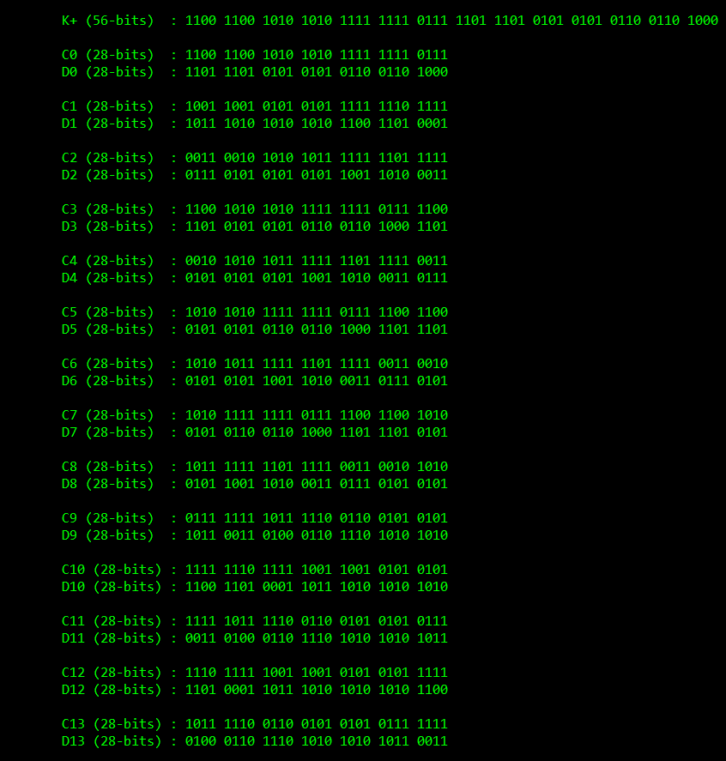

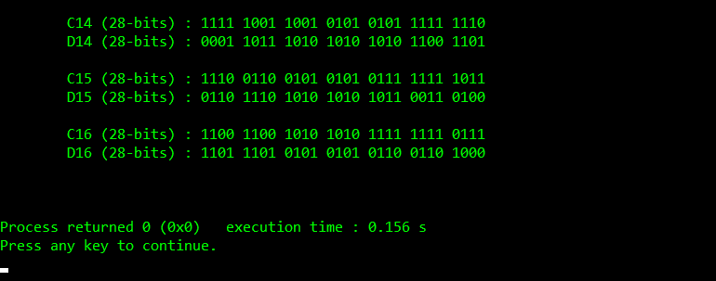

- Write a program to convert the 56-bit key K+ obtained from Q.3 into 48-bit key K1 using permutation PC-2.
PC-2

14 17 11 24 1 5
3 28 15 6 21 10
23 19 12 4 26 8
16 7 27 20 13 2
41 52 31 37 47 55
30 40 51 45 33 48
44 49 39 56 34 53
46 42 50 36 29 32
Note: For the first key K1, we use C1 D1, for the second key K2, we use C2 D2 , and for the third key K3, we use C3 D3.

CODE:

#include<bits/stdc++.h>
using namespace std;

int main() {

int KPlus[56] = {1, 1, 0, 0, 1, 1, 0, 0, 1, 0, 1, 0, 1, 0, 1, 0, 1, 1, 1, 1, 1, 1, 1, 1, 0, 1, 1, 1, 1, 1, 0, 1, 1, 1, 0, 1, 0, 1, 0, 1, 0, 1, 0, 1, 0, 1, 1, 0, 0, 1, 1, 0, 1, 0, 0, 0};
int PC2[48] = {14, 17, 11, 24, 1, 5, 3, 28, 15, 6, 21, 10, 23, 19, 12, 4, 26, 8, 16, 7, 27, 20, 13, 2, 41, 52, 31, 37, 47, 55, 30, 40, 51, 45, 33, 48, 44, 49, 39, 56, 34, 53, 46, 42, 50, 36, 29, 32};
int itr[16] = {1, 1, 2, 2, 2, 2, 2, 2, 1, 2, 2, 2, 2, 2, 2, 1};

// 1. Generating C1, C2, ......., C16 & D1, D2, ...... D16 from K+

// 1.1. Creating C0 & D0 from K+
int C0[28], D0[28];
int it = 0;
for (int cd = 0; cd < 28; cd++)
{
C0[cd] = KPlus[it++];
}
for (int cd = 0; cd < 28; cd++)
{
D0[cd] = KPlus[it++];
}

// 1.2. Creating C1, C2, ......., C16 & D1, D2, ...... D16 from C0 & D0
int C[16][28], D[16][28];

for (int iter = 0; iter < 16; iter++)
{
int z1 = 0;
int z2 = 0;
if (iter == 0) {
for (int x = itr[iter]; x < 28; x++)
{
C[iter][z1++] = C0[x];
D[iter][z2++] = D0[x];
}
for (int y = 0; y < itr[iter]; y++)
{
C[iter][z1++] = C0[y];
D[iter][z2++] = D0[y];
}
}
else {
for (int x = itr[iter]; x < 28; x++)
{
C[iter][z1++] = C[iter - 1][x];
D[iter][z2++] = D[iter - 1][x];
}
for (int y = 0; y < itr[iter]; y++)
{
C[iter][z1++] = C[iter - 1][y];
D[iter][z2++] = D[iter - 1][y];
}
}
}

// 2. Generating K1, K2, ......., K16 in 56 bit format from C1, C2, ......., C16 & D1, D2, ...... D16
int K_56[16][56];
for (int w = 0; w < 16; w++)
{
int out = 0;
for (int w1 = 0; w1 < 28; w1++)
{
K_56[w][out++] = C[w][w1];
}
for (int w2 = 0; w2 < 28; w2++)
{
K_56[w][out++] = D[w][w2];
}
}

// 3. Generating K1, K2, ......., K16 in 48 bit format from K1, K2, ......., K16 in 56 bit format using PC-2
int K_48[16][48];

for (int i = 0; i < 16; i++)
{
for (int j = 0; j < 48; j++)
{
K_48[i][j] = K_56[i][PC2[j]];
}
}

// Printing The Final Outputs :

cout << "\n\n\tK+ (56-bits) : ";
for (int i = 0; i < 56; i++)
{
if ((i + 1) % 4 != 0) cout << KPlus[i];
else cout << KPlus[i] << " ";
}
cout << "\n\tC0 (28-bits) : ";
for (int c = 0; c < 28; c++)
{
if ((c + 1) % 4 != 0) cout << C0[c];
else cout << C0[c] << " ";
}
cout << "\n\tD0 (28-bits) : ";
for (int d = 0; d < 28; d++)
{
if ((d + 1) % 4 != 0) cout << D0[d];
else cout << D0[d] << " ";
}

cout << "\n";
for (int i = 0; i < 16; i++)
{

if (i + 1 <= 9) cout << "\n\tC" << i + 1 << " (28-bits) : ";
else cout << "\n\tC" << i + 1 << " (28-bits) : ";
for (int x = 0; x < 28; x++)
{
if ((x + 1) % 4 != 0) cout << C[i][x];
else cout << C[i][x] << " ";
}
if (i + 1 <= 9) cout << "\n\tD" << i + 1 << " (28-bits) : ";
else cout << "\n\tD" << i + 1 << " (28-bits) : ";
for (int y = 0; y < 28; y++)
{
if ((y + 1) % 4 != 0) cout << D[i][y];
else cout << D[i][y] << " ";
}

if (i + 1 <= 9) cout << "\n\tK" << i + 1 << " (56-bits) : ";
else cout << "\n\tK" << i + 1 << " (56-bits) : ";
for (int j = 0; j < 56; j++)
{
if ((j + 1) % 4 != 0) cout << K_56[i][j];
else cout << K_56[i][i] << " ";
}
if (i + 1 <= 9) cout << "\n\tK" << i + 1 << " (48-bits) : ";
else cout << "\n\tK" << i + 1 << " (48-bits) : ";
for (int k = 0; k < 48; k++)
{
if ((k + 1) % 4 != 0) cout << K_48[i][k];
else cout << K_48[i][k] << " ";
}
cout << "\n";
}
cout << "\n\n\n";

return 0;
}

